# Python programs output screenshots

#### grade_checker.py

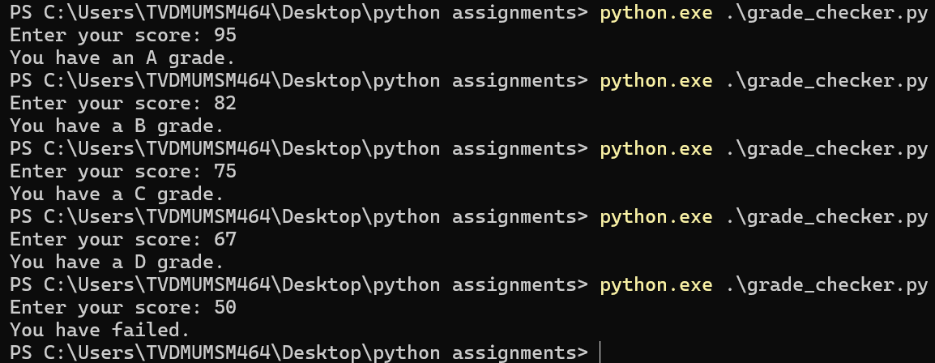

student_grades.py

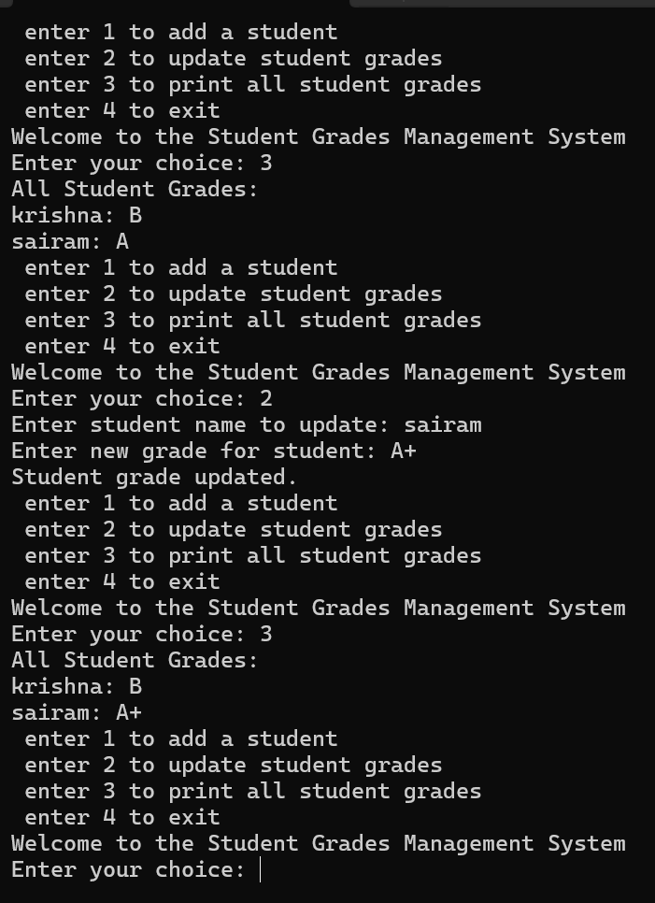

##### write_file.py and read_file.py

